
St. Paul's Cathedral
SRAWBERRIES AND BEYOND
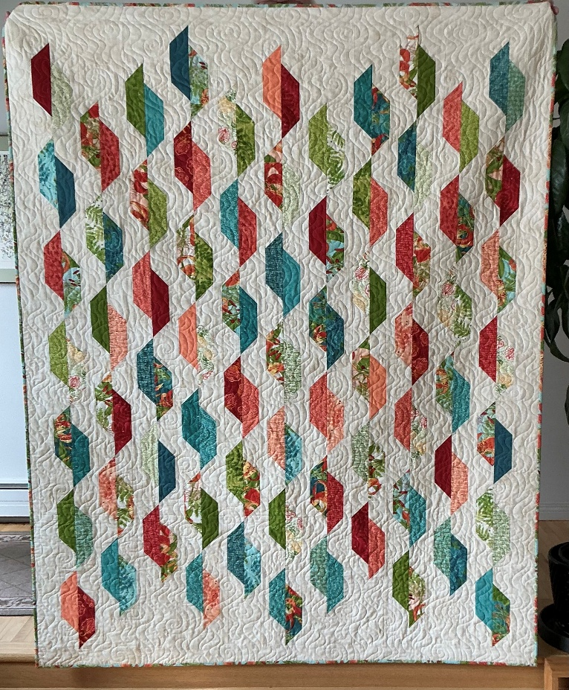
QUILT RAFFLE (Valued at $600.00)
Size 61”x 76.5”

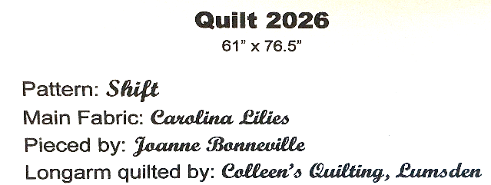

TICKETS: $5.00 ea. or 3 for $10:00
Draw Date: June 6, 2026
At St. Paul’s – 1861 McIntyre St.
License Number: SR26-0143
For tickets to buy or books to sell, Please contact Elvira
@ 306-522-6439 ext. 2

